**Hello World RESTful Web Service**   
  
Write a REST service in the spring learn application created earlier, that returns the text "Hello World!!" using Spring Web Framework. Refer details below:  
  
**Method:** GET  
**URL:** /hello  
**Controller:** com.cognizant.spring-learn.controller.HelloController  
**Method Signature:** public String sayHello()  
**Method Implementation:** return hard coded string "Hello World!!"  
**Sample Request**: http://localhost:8083/hello  
**Sample Response:** Hello World!!   
  
**IMPORTANT NOTE**: Don't forget to include start and end log in the sayHello() method.  
  
Try the URL http://localhost:8083/hello in both chrome browser and postman.

**1. Project Structure**

Create this class:

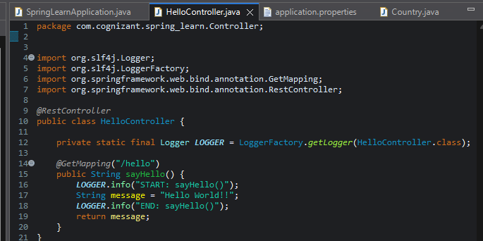

**Update application.properties**

src/main/resources/application.properties:

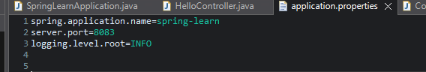

**SpringLearnApplication.java (Main Class)**

Make sure this is your main class:

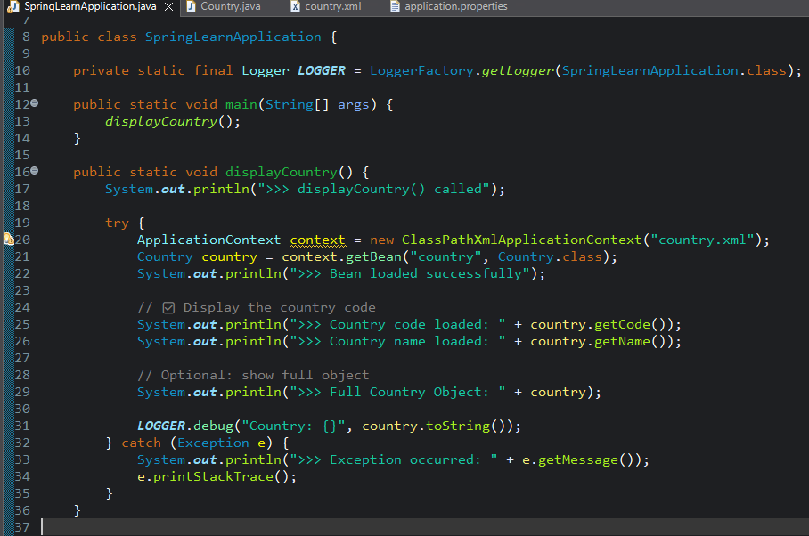

**Output:**

IN Brower:

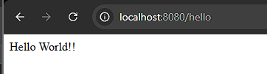

In Postman:

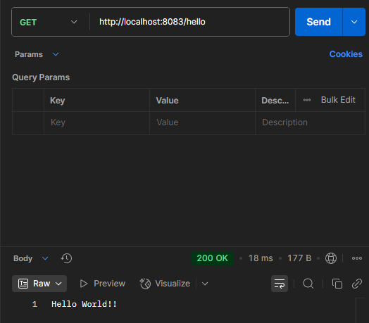

SME to explain the following aspects:

* In network tab of developer tools show the HTTP header details received

**n Chrome Browser Developer Tools (Network Tab)**

**🔹 Steps:**

1. Start your Spring Boot app (SpringLearnApplication.java)
2. Open **Chrome**
3. Enter the URL: <http://localhost:8083/hello>
4. Press **F12** to open Developer Tools
5. Click on the **"Network"** tab
6. Refresh the browser (press F5) to reload the request
7. Click on the /hello request from the list on the left
8. Click on the **"Headers"** tab (top-right panel)

**➤ Request Headers (Sent by Browser):**

| **Header** | **Example Value** |
| --- | --- |
| **GET** | /hello |
| **Host** | localhost:8083 |
| **User-Agent** | Mozilla/5.0 (Windows NT 10...) |
| **Accept** | text/html,application/xhtml+xml,... |

* In postman click on "Headers" tab to view the HTTP header details received

**2. In Postman - View Response Headers**

**🔹 Steps:**

1. Open **Postman**
2. Enter:
   * **Method:** GET
   * **URL:** http://localhost:8083/hello
3. Click **Send**
4. In the **Response section**, click on the **"Headers"** tab (next to "Body")

